|  |  |  |  |  |
| --- | --- | --- | --- | --- |
|  |  |  |  |  |
|  |  |  |  |  |
|  |  |  |  |  |
|  |  |  |  |  |
|  |  |  |  |  |
|  |  |  |  |  |
|  |  |  |  |  |
|  |  |  |  |  |
|  |  |  |  |  |
|  |  |  |  |  |
|  |  |  |  |  |
|  |  |  |  |  |
|  |  |  |  |  |
|  |  |  |  |  |
|  |  |  |  |  |
|  |  |  |  |  |
|  |  |  |  |  |
|  |  |  |  |  |
|  |  |  |  |  |
|  |  |  |  |  |
|  |  |  |  |  |
|  |  |  |  |  |
|  |  |  |  |  |
|  |  |  |  |  |
|  |  |  |  |  |
|  |  |  |  |  |
|  |  |  |  |  |
|  |  |  |  |  |
|  |  |  |  |  |
|  |  |  |  |  |
|  |  |  |  |  |
|  |  |  |  |  |
|  |  |  |  |  |
|  |  |  |  |  |
|  |  |  |  |  |
|  |  |  |  |  |
|  |  |  |  |  |
|  |  |  |  |  |
|  |  |  |  |  |

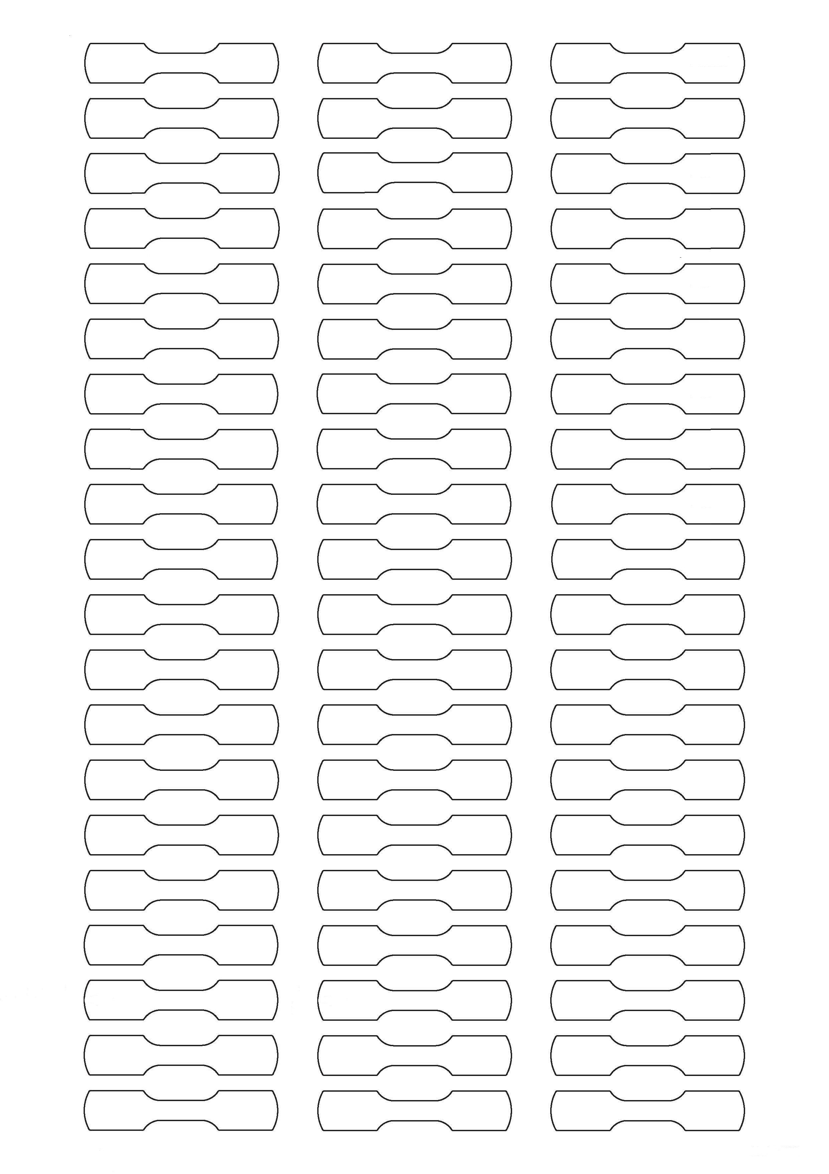

* Bitte Hintergrundgrafik vor dem Drucken löschen (Anklicken & “entf“ Taste drücken) * Delete background graphics before printing (Click and press “delete“) *